Android 6.0 Bluetooth settings method
Open Bluetooth APP> Select Settings> Enter Settings
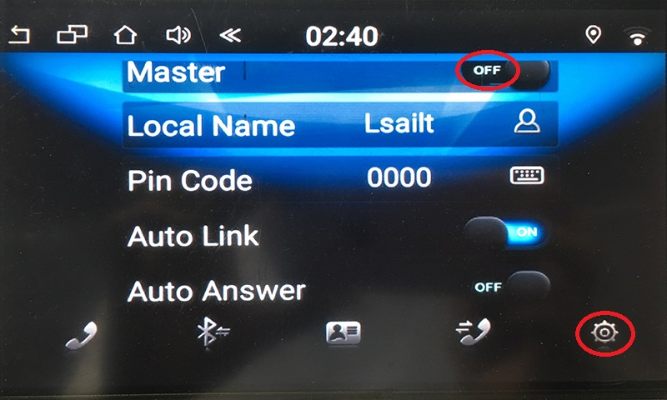
Master-off：
A:Bluetooth handsfree,
Look for lsailt on your phone. The password is 0000
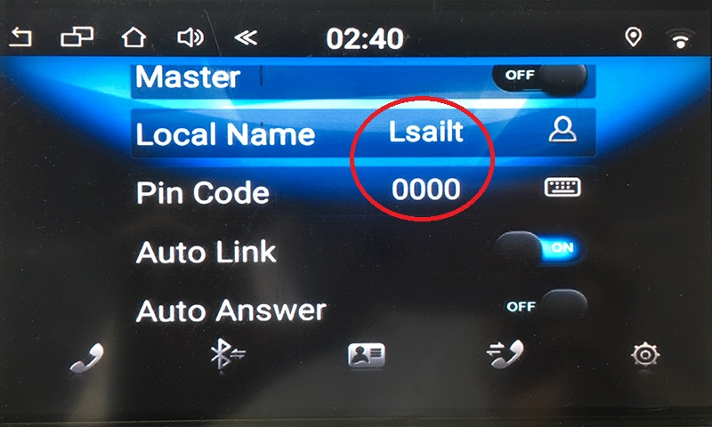
B:Bluetooth obd data reception,
Data Icon> Search> Select master> Join
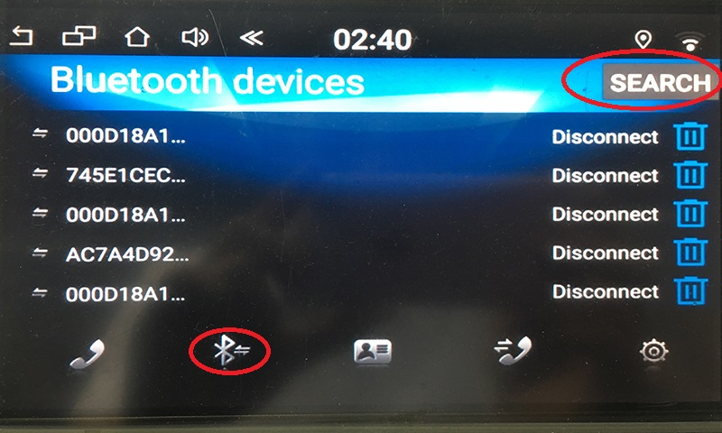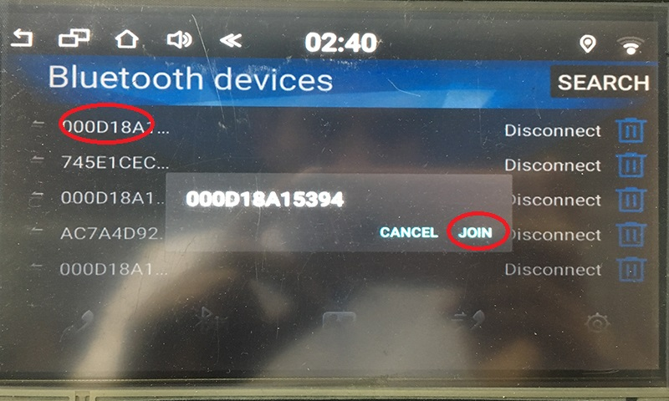
Master-on：Android sounds are sent to other hosts
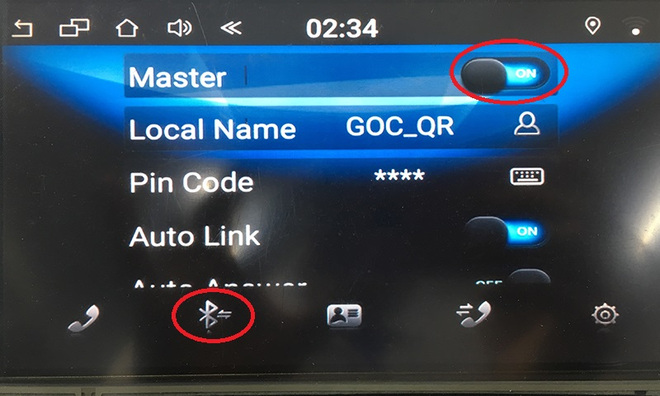
Data Icon> Search> Select master> Join>ok
